AgriVerse: Enhancing Crop Decision-Making Through XAI and Geospatial Weather Integration

# Abstract

**Traditional wisdom and inherited wisdom often dictate which crops to favor in developing economies. Although such approaches preserve communal values, decisions taken based on the current base may lead to a dismal harvest and a gradual decline in valuable land and ecological capital. The present article introduces AgriVerse, a intelligent recommendation platform designed to counter these shortcomings. Organizations shall be developed to coordinate the selection of the crops with detailed regional information on soil nutrition and climate.**

**In addition to their core functions, AgriVerse functions by analyzing a carefully gathered dataset that combines the main features with related meteorological patterns. This integration enables the structure to produce highly contextual agricultural advice. Our method avoids the usual difficulties in the use of several forecasting models. Alternatively, it strategically balances the performance of the computer with architectural clarity. AgriVerse is not just a list of graded suitable crops; it also provides a clear, evidence-based explanation for each recommendation, making it clear to the consumer why it is wrong.**

**Our experimental findings confirm that the outline provides target prediction in support of the current necessary interpretability. AgriVerse is a sensible and reliable support tool ready to be used by individual smallholder farmers as well as by agricultural advisory bodies, thanks to its efficient link with the world of agricultural decision making.**

***Keywords : Crop recommendation, Explainable AI, SHAP, Smart agriculture, Machine learning in agriculture, Weather-aware systems, Counterfactual reasoning, Trust score, Global feature importance, Agricultural decision support.***

# Introduction

In several developing countries, most especially India, agricultural decision-making still mostly relies on heuristic custom and ancestral wisdom. Although these techniques are quite regional, they often result in poor resource distribution and erratic yield patterns over consecutive growing seasons. As underlined by Gangwar et al. [1] and Ghosh et al. [2], the tenacity of these non-scientific methods not only slows down present production but also jeopardizes the long-term ecological and economic sustainability of agriculture systems. The climate catastrophe, which worsens soil deterioration and creates extreme volatility in regional precipitation patterns [3][4], further highlights this need for smart, adaptable decision-support.

Modern developments in Explainable Machine Learning (XAI) present a hopeful path for perfecting these decision-making systems [5]. Although current predictive models integrating soil metrics and historical climatic data have attained great degrees of technical precision, there are major obstacles to acceptance still. Two main flaws seem from a thorough examination of the research: a want of interpretability and a want of reaction to high-frequency, real-time environmental changes. Practitioners without official technical background find models that function as "black boxes," offering recommendations without clear reasoning, fail to earn their trust [6][7].

Directly addressing the twin issues of adaptability and openness is AgriVerse. By dynamically integrating location-specific meteorological information using the Open-Meteo API, our system goes beyond static modeling to guarantee that outputs accurately reflect the farmer's current surroundings. Fundamentally based on an XGBoost-driven predictive engine, the system has been enhanced with a complex explainability suite anchored in SHAP (SHapley Additive exPlanations) values [8].

AgriVerse offers a multi-layered explanatory interface to help to close the gap between field-level implementation and complicated data science. Instead of providing a single data point, the system creates SHAP waterfall plots and global feature significance measures converted into simple-language summaries and counterfactual examples. The ethical need of establishing user confidence in sensitive areas gives rise to this design philosophy [9]. Moreover, we present a specialized "trust score" metric based on established techniques [10] to measure the dependability of every single prediction.

In terms of architecture, AgriVerse can be considered as a complete application using ReactJS front end and Express.js back end for organizing a modular Python machine training grapevine. Farmer supply essential earth parameters (N, P, K, and pH) as the framework unconsciously retrieves temperature, humidity, and rainfall statistics based on location. The synthesis of these variables is then organized in the backend, and a simultaneous eye examination and interpretation report is drawn up. We aim to provide a deployment-ready device that enables wide confidence in precision farming by synthesising quantitative precision and qualitative clarity.

# Related works

The Crop Recommendation Systems have progressed well, moving from the usual statistical approach to more advanced machine training strategies which are better suited to Community Sustainable Environments. In recent years, researchers have been increasingly focused on strike a balance between robust anticipation accuracy and the need for clear interpretation using explainable artificial intelligence (XAI). This part shall confine AgriVerse to the limits of the current farming environment, examine the previous contributions to crop recommendations, explainable mold, and user-oriented design. We draw attention to the lack of prior responsibility that our framework is looking for to prevail.

Jha et al's Ahead of Time Task. [11] demonstrate that support vector machine (SVM) classifier using agroclimatic features can achieve high accuracy. However, the model's 'black box '' fictional character did not provide any explanation of its final product. AgriVerse tackles this transparency issue head-on by integrating SHAP-based explanations that precisely show how each information characteristic contributes to a recommendation, a significant factor for construction boldness among farmers. Similarly, Banerjee et al. [ 12 ] improved performance on Indian data by including climate change projections in Random forest models. While their means effectively capture the long-term shape, they provide little insight into individual forecasts. The present structure, our framework integrates worldwide and municipal interpretation as naturally available up-to-date ecological statistics via geolocation-based API integration.

Patel et al promoted investigations focusing on smallholder farmers. [ 13 ], which improved the hybrid KNN and determination sapling model communicated via a web interface. Though it is available, its apparatus does not provide the user with any deep rationale or option. AgriVerse goes beyond simple rankings by including a special counterfactual coevals faculty, allowing farmers to investigate realistic 'what if '' scenarios and the next-best crop alternatives under stable circumstances such as predicted weather.

In the area of interpretation, Ali et al. [ 14 ] used LIME to clarify yield prediction. Nevertheless, LIME may produce contradictory findings due to its fragility and weak conceptual foundations. AgriVerse, by trusting the SHAP alternatively, provides a mathematically sound and locally precise explanation, which is treasured not only practically but also as a user's study material.

Technical flexibility is restricted due to other frequent challenges in previous systems. For instance, Hossain et al. [ 15 ] created a movable Android app that, although it is portable, relies on an inactive input signal and provides little assistance in the case of missing statistics otherwise location-aware update. Our platform also has a strong grapevine that can produce reliable recommendations even in spite of partial information, while explicitly reporting conviction levels to users. Similarly, although Dey et al. [ 16 ] combined external meteorological APIs, their framework proposes a single crop near a given duration. AgriVerse, by correlation, measures 22 unique crops simultaneously and returns the top three with probability tons and a detailed visual image of the SHAP consequence in the case of a large choice.

A number of existing approaches also address constraints related to geography or structure design. The Singh and Rao ensemble model, for instance, was limited to Rabi season statistics and required a complete input signal. AgriVerse avoids this limitation by real-time geolocation and flexible attribute management that alerts users to the power of missing data over dependability. In contrast, Kumar et al. [ 18 ] investigate complex attention-based nervous networks, which are difficult to interpret and difficult to use in a real agricultural setting. We deliberately choose XGBoost for its robustness to performance and deployment, enhanced by a comprehensive SHAP explanation, rather than pursue an excessively complex architecture. In addition, this choice differs from the inherently explainable yet less scalable fuzzed logic rule-based frameworks of Sharma et al. [ 19 ] ; AgriVerse scaled successfully by train on a dataset of more than 2200 labeled cases.

# Further recent efforts have begun to associate visual image with prediction, despite the continuing fundamental flaw. Yadav et al. [ 20 ] used SHAP to discover the global characteristic significance of wheat production but did not provide instance-level explanation nor synergies. We extend the current one by integrating synergistic SHAP charts and cropped narrative directly into the frontend using Charts.js. Similarly, Brar et al. [ 21 ] construct a fixed backend for multi-crop estimation using LSTMs, but the architecture lacks modularity and counterfactual capabilities. AgriVerse's modular Express and Python backends make it easier to use the cloud and include a deviation-based counterfactual technique for pragmatic alternative suggestions. Lastly, while Das et al. [ 22 ] use explainable Boosting tools (EBMs), which were less capable of multi-class local explanation. AgriVerse uses SHAP's linear attribute to propose powder penetration into the components driving each specific recommendation.

Further recent efforts have begun to associate visual image with prediction, despite the continuing fundamental flaw. Yadav et al. [ 20 ] used SHAP to discover the global characteristic significance of wheat production but did not provide instance-level explanation nor synergies. We extend the current one by integrating synergistic SHAP charts and cropped narrative directly into the frontend using Charts.js. Similarly, Brar et al. [ 21 ] construct a fixed backend for multi-crop estimation using LSTMs, but the architecture lacks modularity and counterfactual capabilities. AgriVerse's modular Express and Python backends make it easier to use the cloud and include a deviation-based counterfactual technique for pragmatic alternative suggestions. Lastly, while Das et al. [ 22 ] use explainable Boosting tools (EBMs), which were less capable of multi-class local explanation. AgriVerse uses SHAP's linear attribute to propose powder penetration into the components driving each specific recommendation.

# Proposed Methodology

The architecture of AgriVerse should be designed to consider the technical challenges of machine learning as well as the pragmatic challenges of field cultivation. Our methodology is based on a modular paradigm, which ensures that all phases, from information consumption to user interaction, are scalable and sustainable. The foundations are structured around four main pillars: a high-fidelity model training grapevine, a dual-purpose prediction and explanation engine, a robust Node.js API gateway, and a fast React-based user interface.

We ensure that the system remains computationally efficient while providing real-time availability by separating the predictive logic from the shipment mechanism. The model train grapevine's focus is on past correctness and generalization, while the explanation engine uses the SHAP (Shapley Additive Explanation) to break down the aforementioned complex prediction into human-readable perspectives. This intentional modularity enables AgriVerse not only to function as a technical classification exercise but also as a coherent, deployable biome whose predictive precision is balanced by extremist openness.

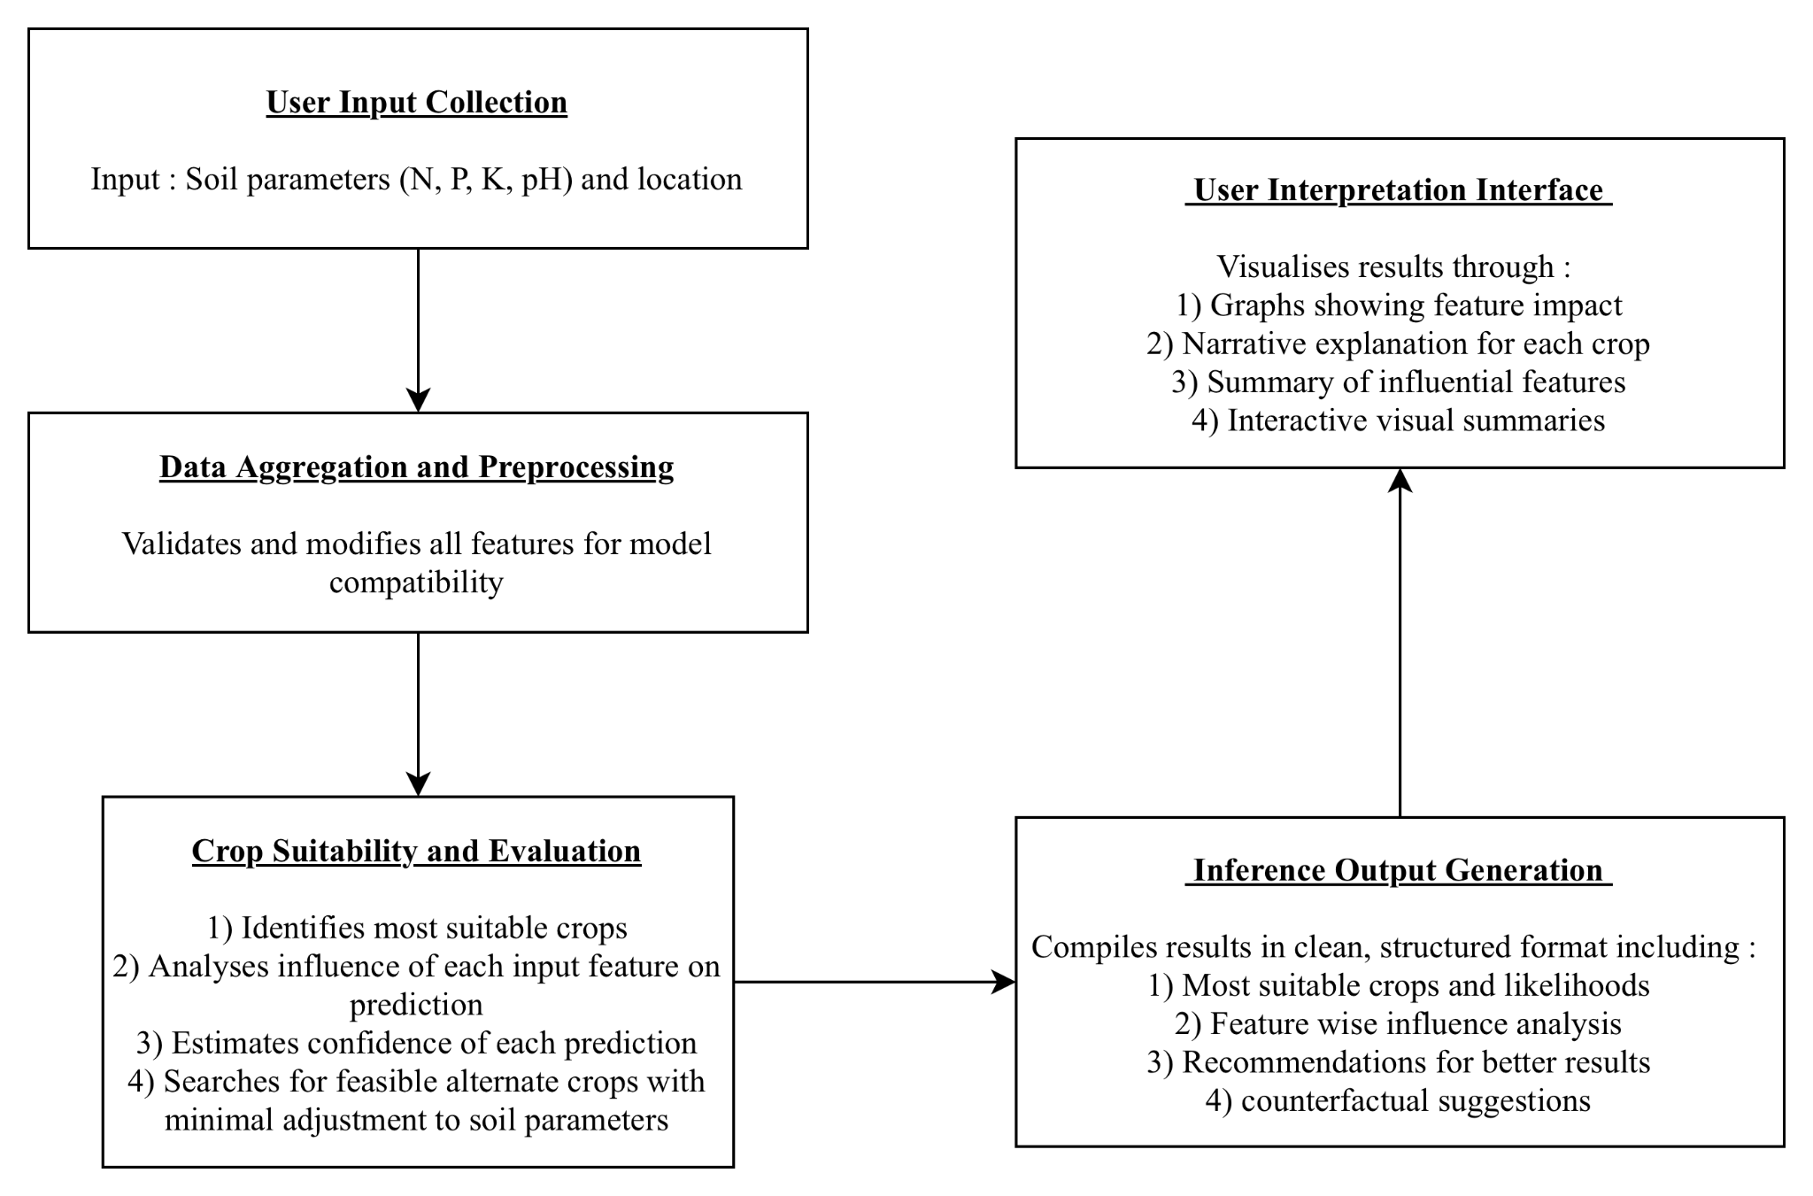

Fig. 1. System flow pipeline

AgriVerse operates in a deliberately structured multi-stage work flow that integrates farmer data with up-to-the-minute ecological facts to produce practical, well-explained crop recommendations. The system starts when the client enters the essential land parameters, nitrogen (N), phosphorus (P), potassium (K), and pH, together with the coordinates of its location. Such coordination naturally accelerates the retrieval of up-to-date community-based meteorological data, including temperature, humidity, and precipitation, via external API integration.

Once land statistics have been combined with real-time meteorological variables, the combined information will be passed to the main appraisal faculty. Here, two key undertakings run side by side a multi-class categorization model to select the mainly correct crop while simultaneously calculating how the corresponding human input influences the result. The organization will conduct a dedicated counterfactual investigation to provide additional, rather than merely a personal superior suggestion. In comparison with a fixed recommendation, which provides a farmer with a realistic choice crop which can develop into feasible with minimal changes to the controllable earth variables, it provides a farmer with a clear roadmap to potential improvements rather than a fixed recommendation.

In the closing measure, all these elements are communicated together in a coherent interpretation report. The report is presented in a simple web interface based on React and has an intuitive visual image accompanied by an easy explanation in a simple organic dialect. This technique ensures that the advice is exclusively targeted and wholly traceable, in addition to being simple for the farmer to grasp and act on. AgriVerse ensures that every suggestion is clear, anchored by a sign, and confirmed by practical advice on better farm organization.

## Model selection and Training

AgriVerse's main objective was to meet three frequently competing requirements: improved forecast accuracy, minimal rotational latency in real-time usage, and robust interpretation. To bridge the gap between the hypothetical world of machine learning and the real world of agricultural decision support, this pillar is of vital importance.

We conducted a comprehensive comparative study on countless benchmark classifiers, including support vector machines (SVM), random jungles, and artificial neural alliances (ANNs), to select the optimal architecture. Our experimental results have led to the choice of XGBoost (Extreme Gradient Boosting) as the main model. Numerous of the algorithm's unique systematic advantages were decisive in the current decision:

* Non-linear Pattern Recognition: Nonlinear Pattern Validation's ability to capture the intricate, nonlinear bonds between Earth's chemistry and meteorological fluctuations that simpler linear models often miss.
* Resilience to Feature Noise: Adaptability to Attribute Noise A built-in capacity to manage multicollinearity and noisy data commonly found in field-collected agricultural data without a significant decline in performance.
* XAI Compatibility: XAI Compatibility In particular, XGBoost's tree-based organization integrates seamlessly with the SHAP (Shapley Additive Explanation) system, allowing uniform and mathematically stable post-hoc analyses.

By a crucial level, XGBoost constructs its prediction using an iterative ensemble method where every subsequent learner is trained to correct the residual error of its predecessor. This polish ensures a highly optimized model which is still sufficiently lightweight for real-time use in a portable alternatively web-based environment. You can describe prediction like:

${\hat{y}}_{i} = \sum{}k = 1^{K}f_{k}(x_{i}) f_{k}∈ ξ$ (1)

Where:

* ${\hat{y}}_{i}$ is the predicted output for instance i.
* $f_{k}$ is the $k^{th}$ regression tree.
* $ξ$ is the space for all the regression trees.
* And K is the total number of trees.

Three main aims in designing AgriVerse's forecast engine were precision, working reliability, and interpretation. This analysis describes the problem as a multiclass classification problem, where the model train is required to differentiate between 22 different crop types. The prognosis lies in the presence of seven essential agronomic components: nitrogen (N), phosphorus (P), potassium (K), soil pH, and three meteorological factors, temperature, humidity, and precipitation.

Discipline facts: preparation grapevine is used in the training process, as shown in Fig. 2. It is followed by a phase of thorough data cleansing and standardization to standardize the attribute scale and reduce the dominance of outliers. Lastly, we applied focused attribute technology to improve the model's ability to identify related forms within the dataset.

The use of Dropout Replica Tactics as a new aspect to our training method. Everywhere in model training, random characteristic subsets were intentionally excluded to mimic the insufficient information scenario common in real world agriculture, such as fragmented dirt trial or other impermanent detector break. By studying the functioning robustly in spite of such imitations, the model added a sensible force, thus becoming a further reliable advisory tool underpinned by the frequently encountered non-ideal statistical circumstances encountered on the meadow.

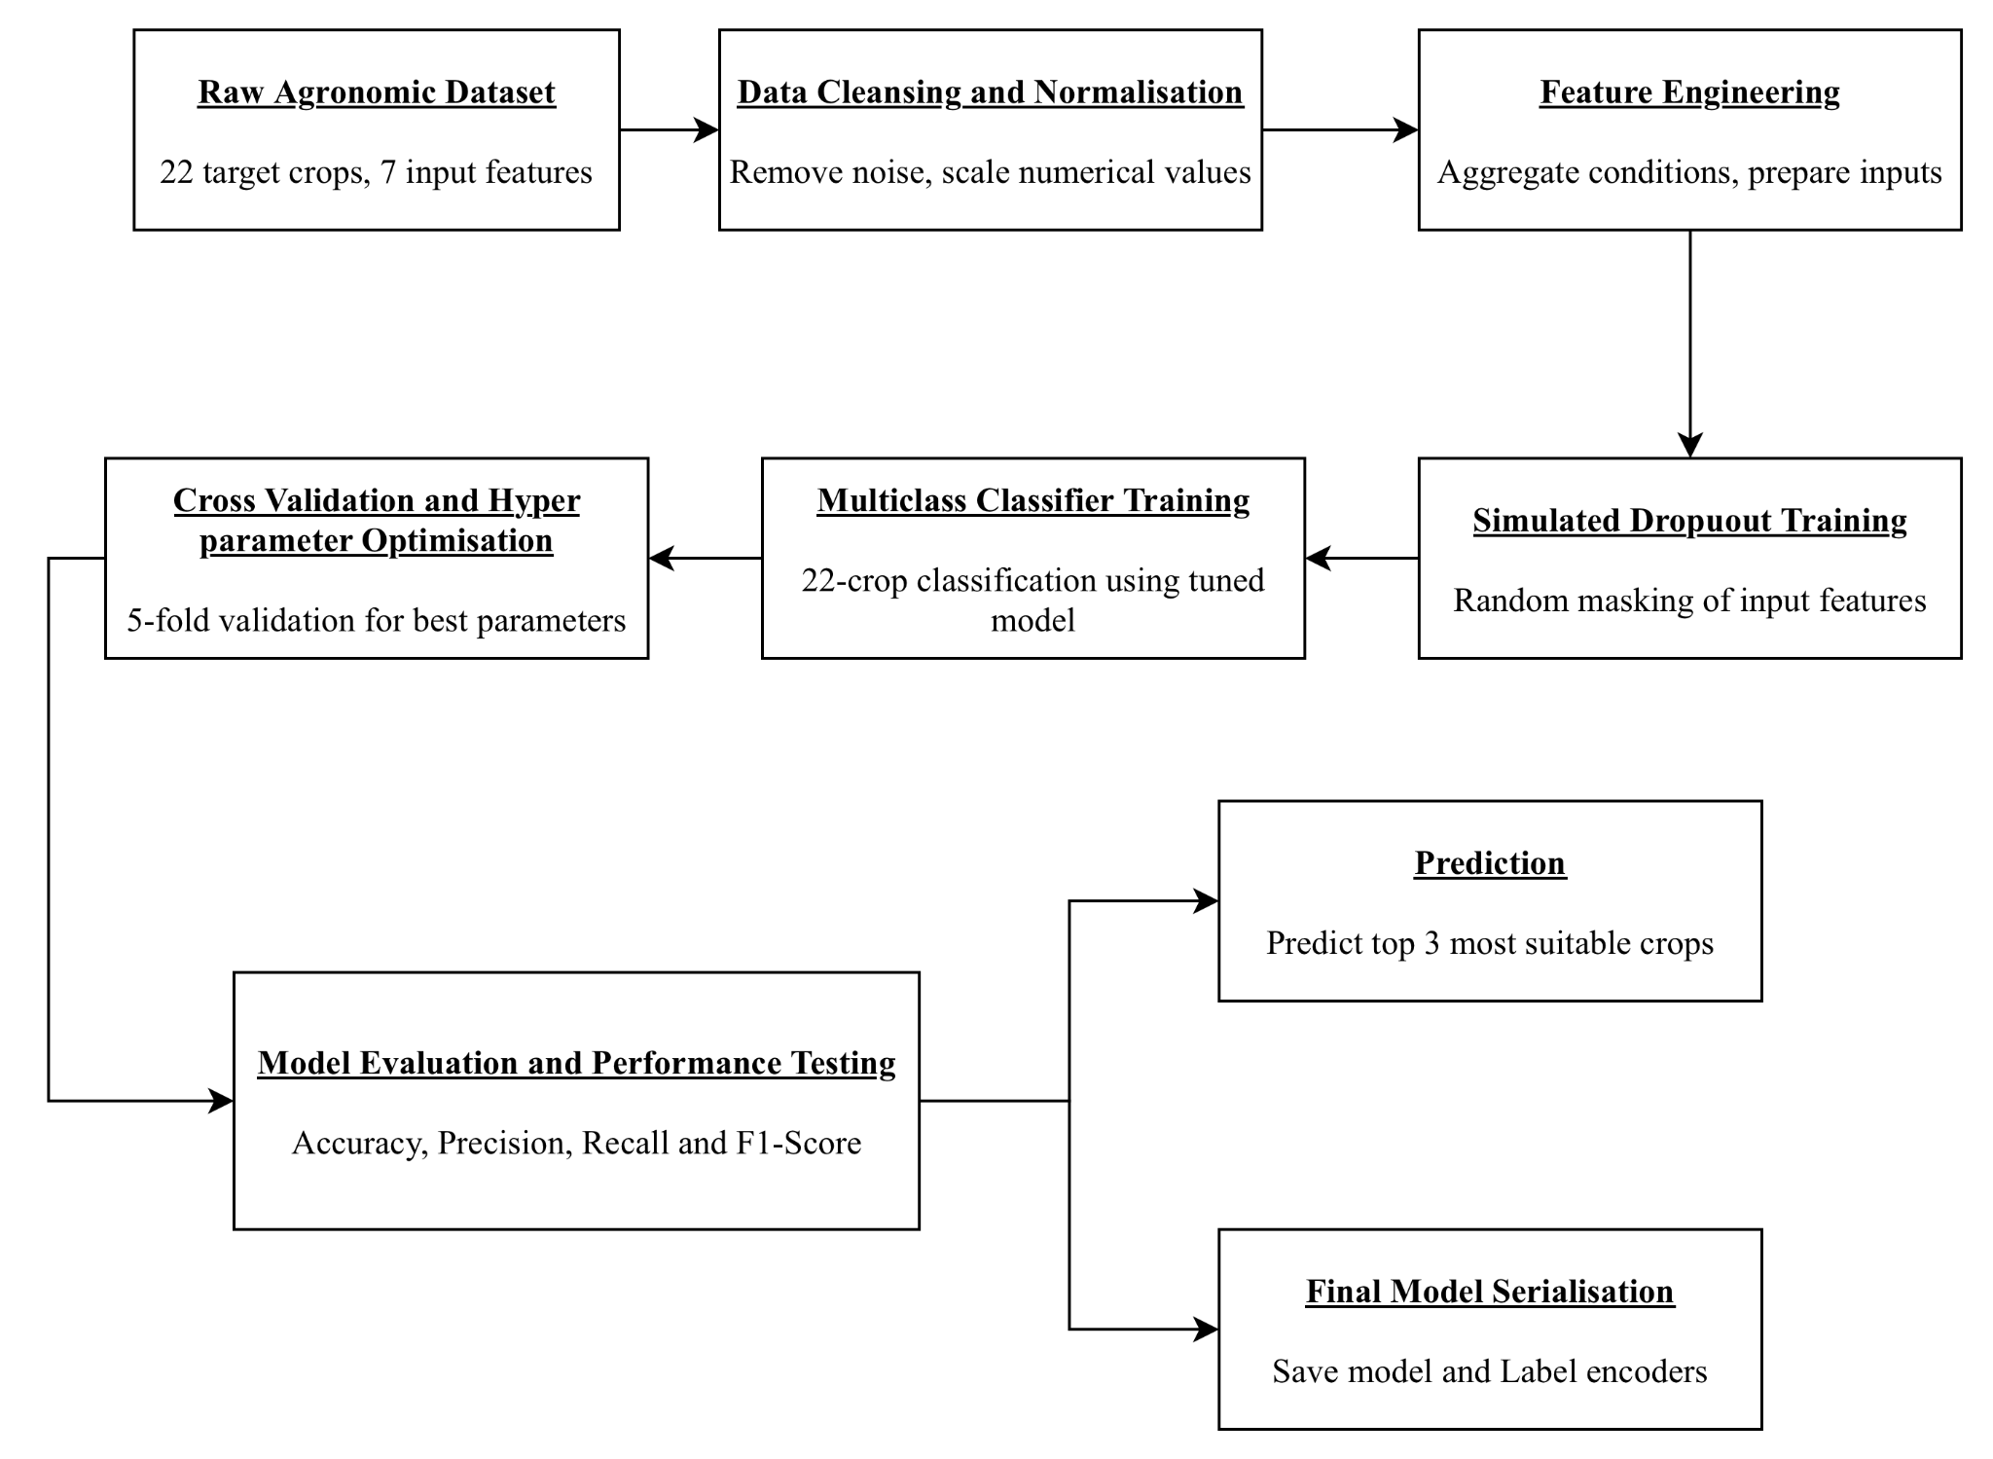

Fig. 2. Flowchart for Crop Recommendation Model

We used a structured hyperparameter tuning method to maximize the performance of the model and facilitate strong generalization. The current trust in grid search combined with 5-fold cross-validation to thoroughly adjust the major parameters including maximum timber depth, knowledge acquisition ( Basque Homeland and Freedom ), and sampling ratio. The adapted model has given outstanding results, achieving a classification accuracy of 96.7 % in independent trials. The systemically increased precision, recall, and F1 scores across all 22 crop classes confirmed that the model performed accurately without preferentially selecting any particular class.

Once validated, the final model is serialized using standard pickle approaches. This step ensures a smooth and error-free transition from the development phase to the live production backend.

Conscious of the fact that benchmark accuracy in a controlled context frequently drops in applied applications, we introduce a special dropout-based training tactic. By randomly dissembling a subset of feedback features during train epochs, we enable the model to detect alternative bonds surrounded by incomprehensible aspects. The current method successfully retroflexes the kind of fault normally encountered in smallholder farming, referred to as a malfunctioning detector or otherwise inaccurate land measurement. As a result, the method significantly improves robustness, allowing AgriVerse to provide reliable, confidence-calibrated recommendations even in combination with incomplete inputs, an important capability for reliable operation in areas, as well as unreliable internet entry or limited on-farm testing capital.

## Prediction and Model Result Explanation

A foundational tenet of the AgriVerse architecture is the commitment to "transparent-by-design" artificial intelligence. To transition from a purely predictive tool to a credible decision-support system, we integrated SHAP (SHapley Additive exPlanations) as the primary interpretive engine. Unlike heuristic-based explanation methods, SHAP is rooted in the axiomatic principles of cooperative game theory, providing a mathematically rigorous method for attributing the "payout" (the model's prediction) to the individual "players" (the input features).

This framework allows AgriVerse to decompose complex, non-linear outputs into the specific marginal contributions of variables like soil pH or precipitation. By adopting this approach, we ensure that the system satisfies two critical properties for agricultural trust: local accuracy, where the explanation precisely mirrors the model’s logic for a specific farm, and global consistency, ensuring that the relative importance of features remains coherent across the entire dataset. This layer of transparency is not merely a technical addition; it is an ethical bridge that allows users to move from passive receipt of data to active, informed understanding.

$ϕ_{i}=\sum_{S ⊆ N_{i}}{}\frac{|S|!(|N|-|S|-1)!}{|N|!}[f(S∪\{i\})-f(S)]$ (2)

Where :

* $ϕ_{i}$ is the SHAP value of feature i
* S is the the subset of features not containing i
* N is the set of all input features
* f(S) is the model prediction when using features only in subset S

While AgriVerse receives the start of the runtime input signal, it selects the three most promising crop options based on the probability samples of the XGBoost model's predict_proba procedure. To make these predictions transparent, the structure uses the TreeExplainer from the SHAP library to calculate the precise attribute inputs for each campaign crop.

We designed a two-tiered interpretability structure that offers both fine-grained details and broader contextual understanding :

* Localized Feature Attribution (Per-Crop): For the respective superior recommendations, AgriVerse provides a dedicated horizontal barroom table showing the course and magnitude of sway for each contribution variable. For instance, it may contain a method by which sufficient rainfall is strongly supported by rice, while an unfavorable soil pH is simultaneously limiting its viability. This visual image helps users to follow the competition with the unique ecological parameters of each individual plant.
* Global Structural Importance: We precompute a dataset-wide value plot during training. The current graph shows the main influential feature of the model as a whole, by average, the absolute SHAP standards across the entire training sample. It is a useful high-level guide for scientists and extension workers, drawing out the mandatory driver shaping the structure's judgments.

One's multicrop analogy capability is a central breakthrough in AgriVerse. Unlike the majority of the existing models, which explain only the individual superiority, our model generates a neighborhood SHAP influence plot for the top three campaigners once. Exposing them side by side allows a comparison of leads, allowing farmers and advisors to see precisely why the individual crops lie outside the different individuals and to understand the ecological trade-offs in their detailed location. A more sophisticated and nuanced verdict is supported by the current extensive interpretation.

## AI Generated Report System

AgriVerse includes a dedicated organic language synthesizer to support farmer rotation in realistic on-farm options. The present component converts the numeric results of the SHAP characteristic analysis into a simple, narrative explanation. By systematically interpreting the core logic of the model, it produces a personalized report on the individual recommended crop, making the reasoning accessible to the user without any technical background.

Each report is organized in a clear, structured way:

1. Confidence-Weighted Prediction: The Confidence-Weighted Predictive explanation starts, together with the higher recommended variety and its associated probability mark, and immediately shows the confidence of the organization in the suggestion.
2. Supportive Drivers: The supporting driver shall then be emphasized as the oinnacle supporting feature, which together with the favourable SHAP values, as well as the description of the ways in which detailed soil conditions in the second location contribute positively to the cultivation of the cultivated area.
3. Growth Constraints: The report then defines the 'impeding features' together with the harmful SHAP principles and indicates external natural factors such as inadequate pH or otherwise excessively heavy rainfall which may restrict the second performance of the plant.
4. Prescriptive Insights: Prescriptive perceptions rather than stopping next to account, the faculty compares the consumer's current situation in order to obtain the optimum scope (derived from the agronomic form of the training data ) and gives real recommendations, such as the modification of the soil or the adjustment of the surface.
5. Contextual Warnings: While facts are incomplete, for instance, assuming the meteorological API fails, the system explicitly warns the user about approximately every conjecture made and possible outcomes in terms of accuracy.

The real strength of the current faculty lies in its ability to translate natural analytic consequences into effective, relevant advice. AgriVerse makes clear farming accessible and enlightening by detecting valuable deviations from the ideal conditions and modeling them as achievable steps. The present empowers farmers to move away from intuition-based solutions to aware, evidence-based approaches that optimize energy. They're under their control now.

## Counterfactual Suggestion Engine and Trust Score

AgriVerse has also integrated a counterfactual inspection engine designed to support flexible, adaptive farm organization to further enhance its potential utility. Unlike standard recommendation structures, which merely present an inactive ranking, this engine selects a' next-best '' alternative, a plant that may be highly feasible by a targeted, manageable change in soil chemistry.

I nstead of defaulting to the second-highest probability end product, the engine performs a nuanced optimization by calculating the Euclidian distance between the customer's contemporary Earth profile (N, P, K, pH) and the idealized centroid of the substitute crop types established in the training dataset. In particular, to ensure that the recommendation remains stable around the world, irreversible sustainable variables such as temperature and rain are excluded from this distance calculation. The method ensures that the proposed substitute is not simply a statistical runner-up but a pragmatically achievable goal which can be achieved using standard ground modification techniques.

A dedicated trust mark metric has been developed to bridge the psychological gap between different end products and prairie implementation. The 'predictability margin ', which represents the delta between the probability of the highest ranked crop and its closest rivals, is primarily used to calculate the'reliable index.'. In order to promote transparency, the current mark must be dynamically sanctioned if the framework detects facts of lacuna, such as the Miss Earth parameter or sensor failure. The result numeric value can then be mapped to simple qualitative labels, High, Moderate, or Low, enabling farmers and extension agents to immediately estimate the degree of certainty in the second advice provided by the structure. This double emphasis on practical possibility and evident reliability ensures AgriVerse's role as a reliable associate in the field of precision farming. The final trust score is calculated using the following equation :

$Trust Score=\frac{P_{top}-μ_{P_{rest}}}{1 - μ_{P_{rest}}}×100$ (3)

Where :

* $P_{top}$ is the probability of the top predicted crop.
* $μ_{P_{rest}}$ is the mean probability of the other crops.

Additionally, if any features are missing, the trust score module penalizes the score and notifies the frontend to alert the user about reduced reliability.

## Backend Integration

AgriVerse uses the Express.js backend to provide sensitive information on the Internet. The present server acts as a reliable intermediary, connecting the intuitive front end to the computationally intensive Python-based machine for acquiring knowledge. This architecture imposes a clear distinction between the challenges, ensuring that demand analysis procedures do not adversely affect the speed of the platform or the interactivity of the platform.

Upon receipt of a JSON request from the client, the Node.js backend initiates a prediction grapevine. It arranges for the name of the Python environment via the given shell execution to pass the provided dirt and weather parameter as a command-line argument to the inference script. The script follows the statistics and returns a complete, serialized JSON output for the backend to manage. The waiter effectively delivers inactive and precomputed materials identical to high-resolution crop images, dynamically generated SHAP visual image, and international model relevance chart, in addition to supervising such on-demand calculations.

The relevant buyer's question culminated in the delivery of a highly structured JSON missile, precisely formed to give an integrated impression of the recommendation. The current response shall be divided into four important information grades :

1. The Predictive Tier: The predictive grade takes into account the three main crops, the individual attachment to them by its probability mark, and the associated ocular properties.
2. The Interpretative Tier: In addition to the precomputed Worldwide Attribution Significance Prosody, the interpretative grade provides details on the SHAP aspects for every major campaigner.
3. The Actionable Tier: Presents location-specific counterfactual alternatives and a user-friendly, qualitative trust score.
4. The Narrative Tier: The narrative grade provides a clear, synthesized Natural Language Report that translates analytic output into clear, sensible agricultural guidance.

This modular architecture significantly enhances the system's scalability. This enables independent polishing and updating of the machine learning model, which does not require any changes to the API logic or front end interface. AgriVerse maintains a balance between technical perfection and sensible, deployable functionality in a wide range of agricultural environments by separating the resource-intensive Python engine from the API distribution layer.

## Frontend Architecture

The frontend will be built using ReactJS and a fresh, attainable layout theme in agricultural sunglasses of green and style fully in Georgian font for professionalism. On initial startup, the interface prompts the user to either manually enter the dirt parameter or to choose to share geolocation.

A dynamic table captures user inputs for features such as Nitrogen, Potassium, etc. Features already selected are removed from the dropdown, preventing duplicates. After submission, the top three predicted crops are displayed with circular cropped images.

Clicking on any image opens a modal popup showing:

* Crop name and predicted probability
* SHAP-based feature impact chart rendered using Chart.js
* AI-generated narrative report

Below the main display area, the Trust Score Card, Counterfactual Suggestion, and Global Importance Chart are shown in a readable, segmented format.

The frontend dynamically updates its elements based on API responses and gracefully handles errors or missing data. It also offers compatibility with both desktop and mobile devices via responsive CSS.

# Results and Discussion

This section elaborates on the empirical findings of the proposed Explainable AI-based Crop Recommendation System. The results are dissected both quantitatively, in terms of classification performance metrics, and qualitatively, in terms of explainability, usability, and robustness. The outcomes demonstrate not only the predictive accuracy of the model but also its practical deployability and interpretability, which are essential for agricultural decision support systems.

## Dataset and Preprocessing

The elemental data used in the current study, covering 22 distinct cultivars, together with 7 primary agroclimatic features: nitrogen (N), phosphorus (P), potassium (K), temperature, humidity, pH, and rainfall. The relevant information guide designates the aforementioned natural and earth features for the right crop label. To ensure consistency, the dataset was normalized, the missing standards were eliminated, and the categorical encoding was not important since the entire feature was a numeral.

The data divided into 80 % training and 20 % testing so as to maintain a balance between the classes for the entire crop label. Trait escalating was not used in academic writing applied as XGBoost for smooth handling of natural aspect beliefs.

## Model Performance Evaluation

To evaluate the predictive quality of our XGBoost-based classifier, we computed several key classification metrics including accuracy, precision, recall, and F1-score on the test set on the basis that the confusion matrix was generated to visualize the classification consistency across crops as shown in Fig. 3. It helps identify potential class-level confusions such as crops with similar environmental profiles being misclassified.

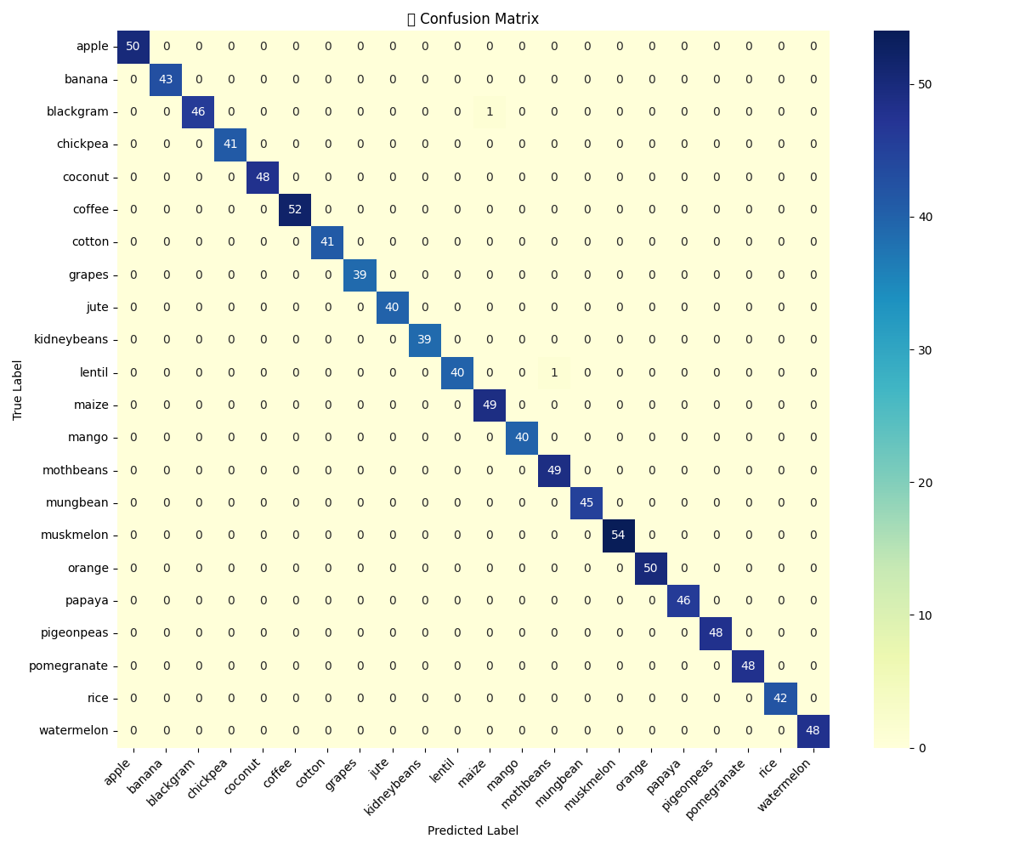

Fig. 3. Confusion Matrix

Using this confusion matrix, the following metrics were computed using stratified train-test splits to ensure class balance across the 22 crop categories.

1. Accuracy : It is the ratio of number of correctly identified images and number of total input images.

$Accuracy = \frac{TP + TN}{TP + TN + FP + FN}$ (4)

1. Precision : It is the ratio of correct outcomes and total positive outcomes delivered by the model.

$Precision = \frac{TP}{TP + FP}$ (5)

1. Recall : It is the ratio of correct positive outcomes given by the model to the actual positive outcomes.

$Recall = \frac{TP}{TP + FN}$ (6)

1. F1 - Score : The harmonic mean of precision and recall, offering a single metric for evaluating model’s performance.

$F1 Score = 2×\frac{Precision × Recall}{Precision + Recall}$ (7)

The model reached a final accuracy of 99.80% while the detailed classwise metrics are as shown in Table 1 following the above calculations.

Table 1. Performance Metrics For Different Classes of the Model

|  |  |  |  |
| --- | --- | --- | --- |
| **Crop Class** | **Precision** | **Recall** | **F1 Score** |
| Apple | 1.00 | 1.00 | 1.00 |
| Banana | 1.00 | 1.00 | 1.00 |
| Blackgram | 1.00 | 0.98 | 0.99 |
| Chickpea | 1.00 | 1.00 | 1.00 |
| Coconut | 1.00 | 1.00 | 1.00 |
| Coffee | 1.00 | 1.00 | 1.00 |
| Cotton | 1.00 | 1.00 | 1.00 |
| Grapes | 1.00 | 1.00 | 1.00 |
| Jute | 1.00 | 1.00 | 1.00 |
| Kidneybeans | 1.00 | 1.00 | 1.00 |
| Lentil | 1.00 | 0.98 | 0.99 |
| Maize | 0.98 | 1.00 | 0.99 |
| Mango | 1.00 | 1.00 | 1.00 |
| Mothbeans | 0.99 | 1.00 | 0.98 |
| Mungbeans | 1.00 | 1.00 | 1.00 |
| Muskmelon | 1.00 | 1.00 | 1.00 |
| Orange | 1.00 | 1.00 | 1.00 |
| Papaya | 1.00 | 1.00 | 1.00 |
| Pigeonpeas | 1.00 | 1.00 | 1.00 |
| Pomegranate | 1.00 | 1.00 | 1.00 |
| Rice | 1.00 | 1.00 | 1.00 |
| Watermelon | 1.00 | 1.00 | 1.00 |

## Local Interpretability via SHAP

The system integrates SHAP (SHapley Additive exPlanations) to provide instance-level explanations. For each user input, the top three recommended crops are not only predicted but also visualized using SHAP bar charts showing the contribution of each input feature (Nitrogen, Phosphorus, pH, etc.) to the final decision.

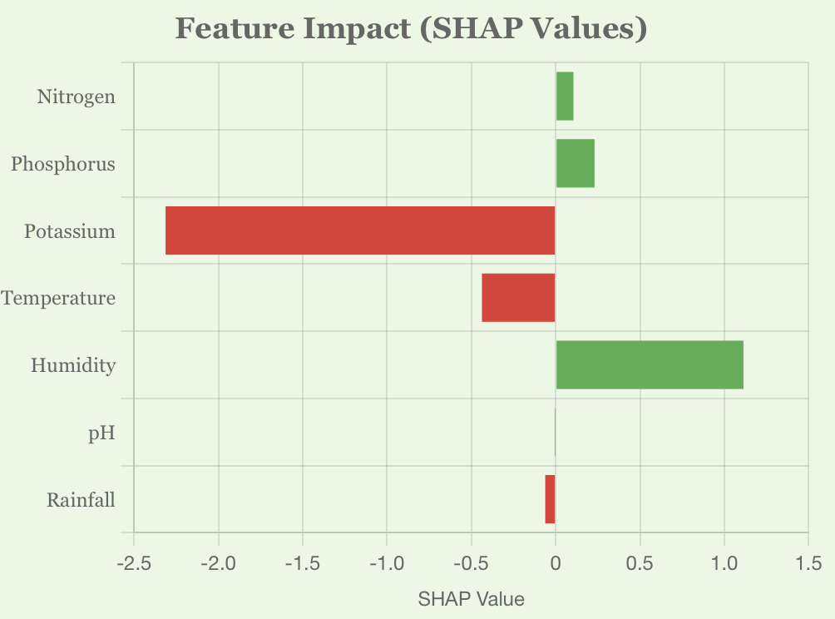

Fig. 4(a) Papaya

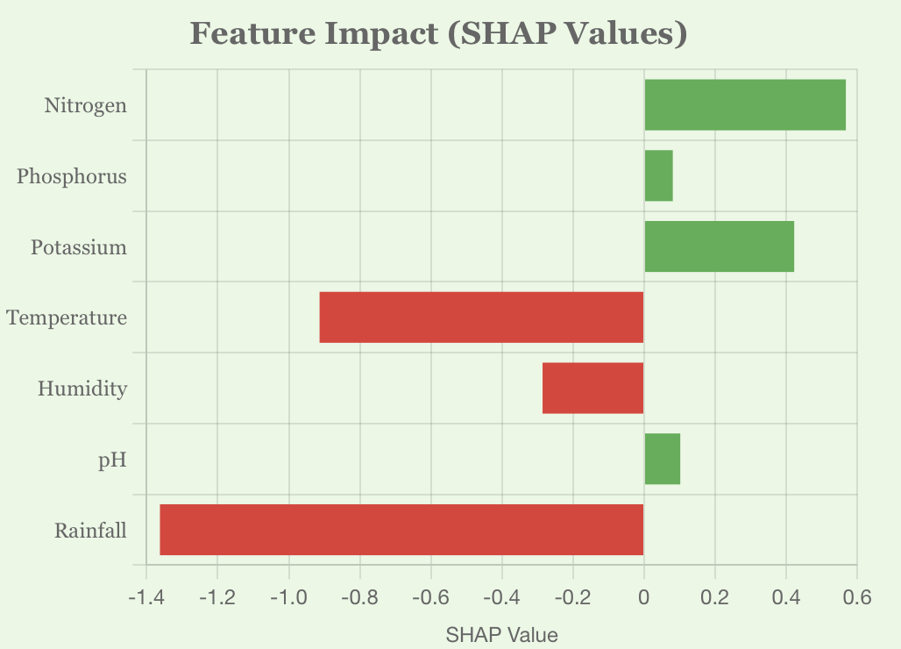

Fig. 4(b) Jute

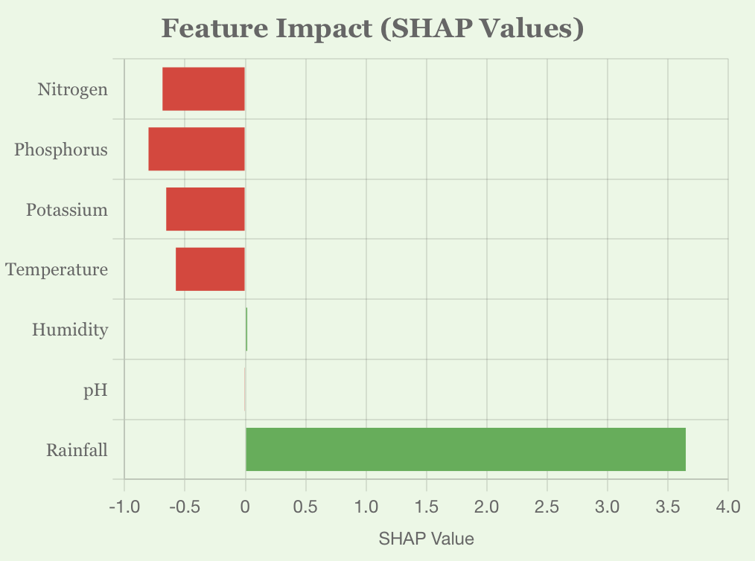

Fig. 4(c) Muskmelon

Fig. 4. SHAP Explanation Plots for top Three Recommendation

Plots in Fig. 4. reveal the exact reasoning behind a recommendation, such as high rainfall and pH supporting rice cultivation while excess potassium could hinder coffee growth. This local interpretability builds user confidence and opens avenues for agronomic discussions.

## Global Feature Attribution

Beyond per-instance explanations, we also computed the global feature importance based on SHAP values aggregated across the entire training set. Fig. 5. outlines which features have the greatest impact on crop decisions irrespective of the user input.

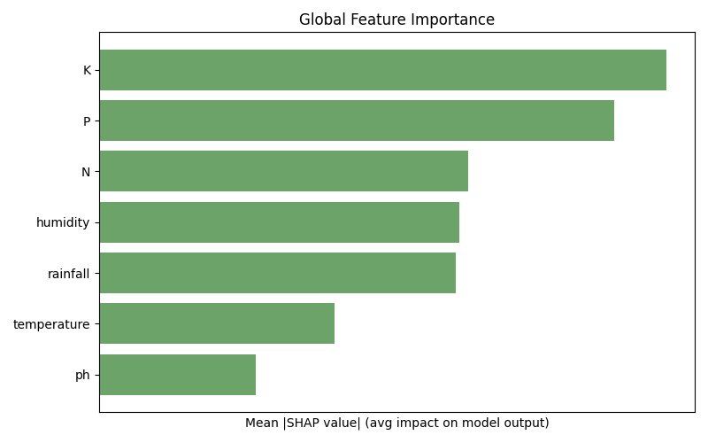

Fig. 5. Global Feature Importance

## Trust Score, Prediction Confidence and Counterfactual Suggestions

To quantify the reliability of each prediction, we introduced a Trust Score module. This score is derived from the confidence gap between the top prediction and the runner-up, normalized with a threshold margin. The output includes Trust Level (High, Moderate, Low) and Confidence Score (as a percentage) as shown in Fig. 6.



Fig. 6. Trust Score Module

Going beyond explanation, our system offers counterfactual suggestions, minimal adjustments to the controllable features (N, P, K, pH) to make another viable crop a better fit which has been clearly depicted in Fig. 7. This is particularly useful when the top crop is not feasible due to market or logistical constraints.

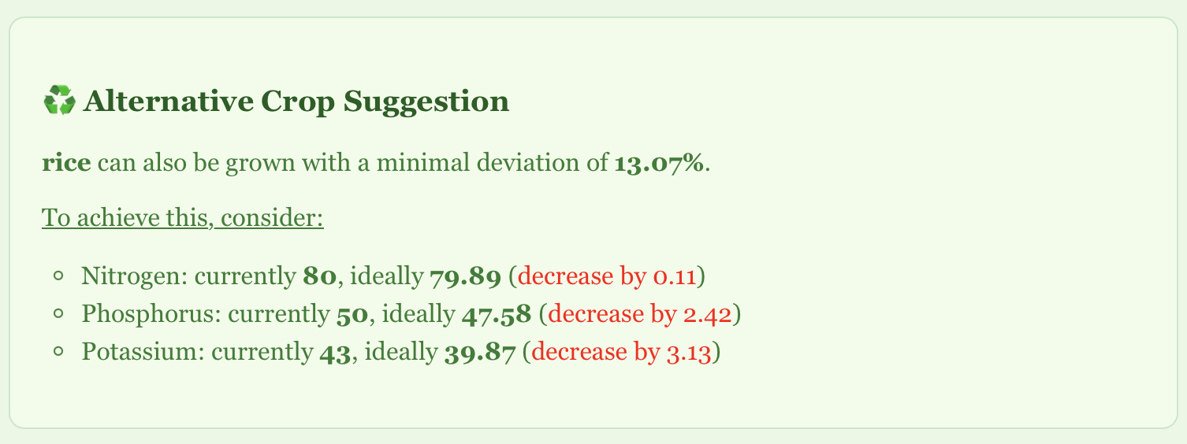

Fig. 7. Counterfactual Crop Suggestion

The system computes per-feature deviation from ideal crop conditions and identifies the next best crop that requires the least intervention. Weather-based features like rainfall or humidity are excluded from this computation to focus only on soil-amendable variables.

## System Usability and Web Deployment

To facilitate real-time access and ease of use, the entire pipeline is deployed via a web interface as shown in Fig. 8. The user enters available inputs through an intuitive form with live condition tracking. Once submitted, results are dynamically visualized and explained.

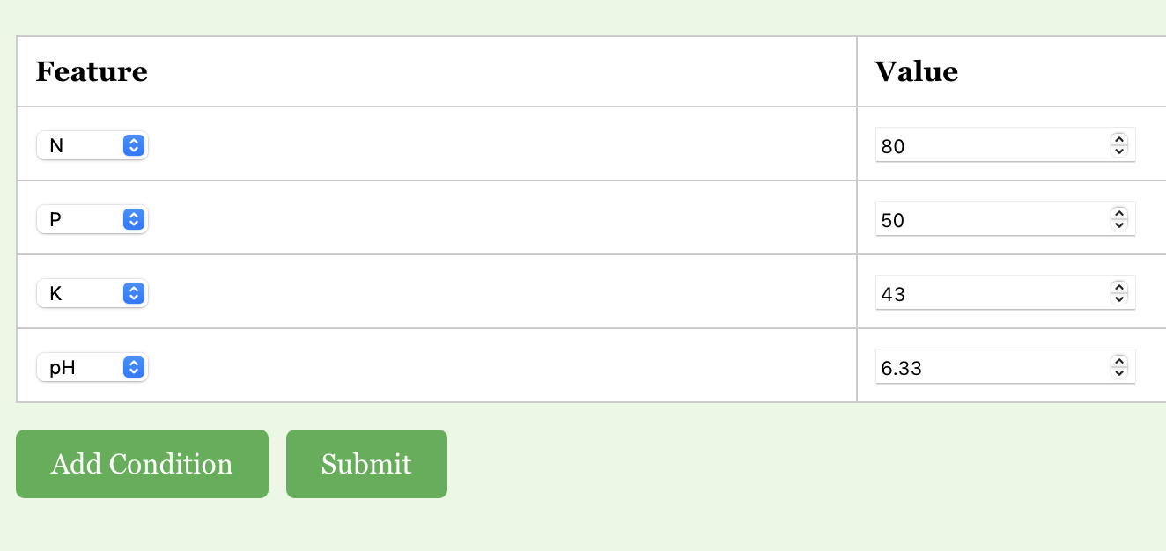

Fig. 8(a) Input

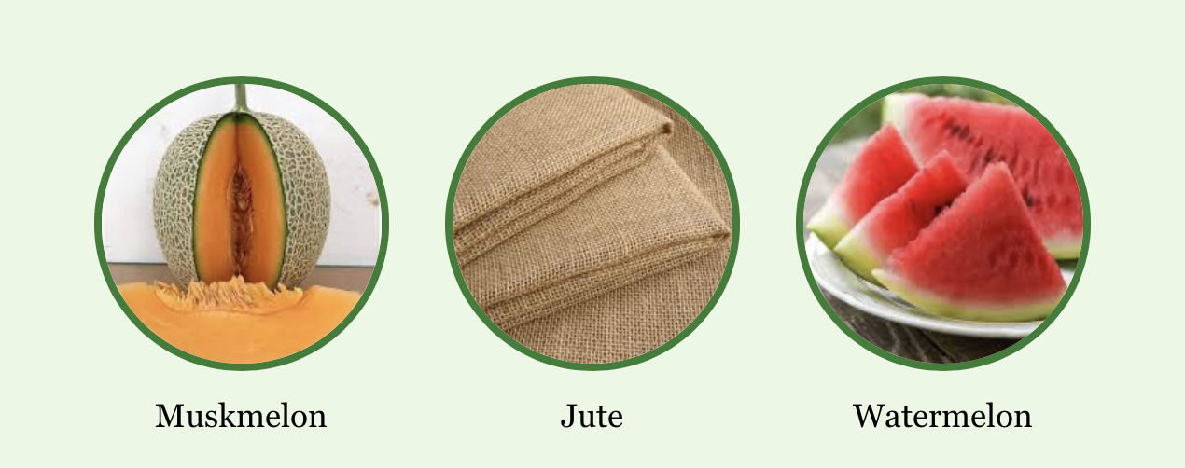

Fig. 8(b) Top three Recommended Crops

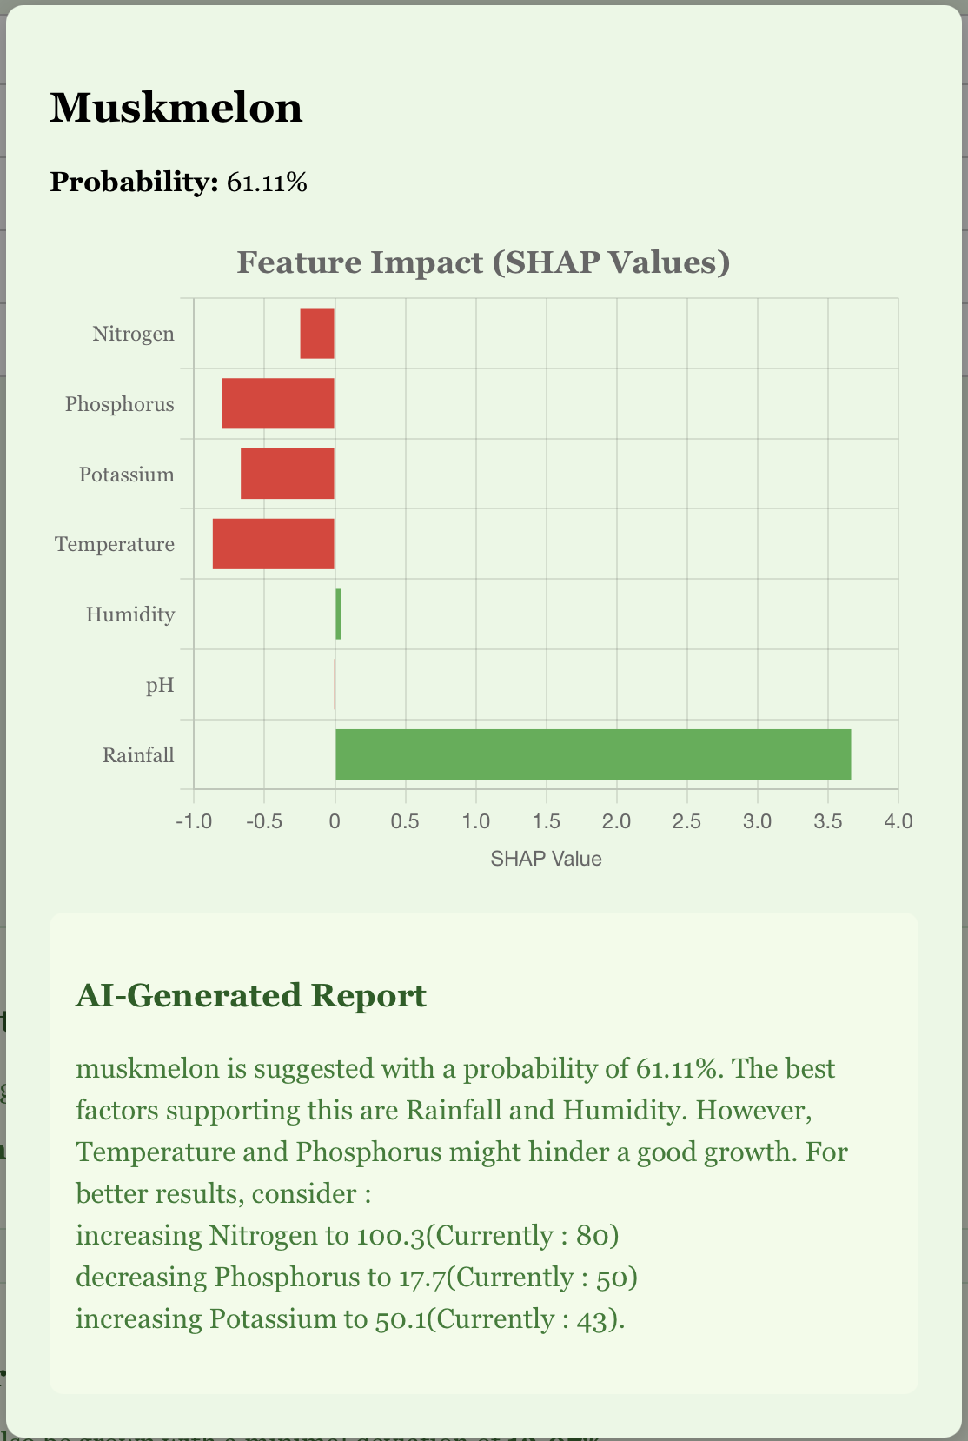

Fig. 8(c) Detailed Crop Suggestion(Modal)

Fig. 8. A glimpse of the web interface

# Conclusion and Future Scope

In this research, we developed and deployed a fully functional Explainable AI-powered Crop Recommendation System that bridges the gap between black-box machine learning predictions and farmer-accessible interpretability. Our pipeline, built upon an XGBoost classification model, leverages SHAP-based explainability to generate intuitive visual and textual insights, making it highly interpretable for agronomists and non-technical stakeholders alike.

The system not only predicts the top three suitable crops for a given set of environmental and soil parameters but also explains the rationale behind those predictions using local SHAP plots, global feature importance visualizations, trust scoring mechanisms, and counterfactual suggestions. By integrating real-time weather data from Open-Meteo APIs and deploying a fully responsive frontend, we provide users with a seamless and intelligent decision-support experience.

The interpretability layer was instrumental in ensuring that stakeholders understood not only what the system was recommending, but also why and how the recommendations could be improved, an essential factor in promoting trust and adoption among farming communities. While the current system offers a robust and explainable crop recommendation engine, several avenues for future enhancement exist:

1. Sensor-Based Real-Time Soil Monitoring: Future iterations of this system can be integrated with IoT-based soil sensors capable of measuring real-time Nitrogen (N), Phosphorus (P), Potassium (K), and pH values. These sensors can be deployed directly in the field, transmitting data wirelessly to the backend. This would eliminate manual data entry, reduce human error, and enhance the granularity and reliability of the input data.
2. Region-Aware Fine-Tuning: Training separate models or fine-tuning the existing one for specific agro-climatic zones can lead to more context-aware recommendations, especially for geographically diverse countries like India.
3. Fertilizer and Irrigation Planning: The model can be extended to not only suggest crops but also recommend specific fertilization plans, irrigation cycles, and crop rotation schedules tailored to user inputs.
4. Adaptive Learning from Feedback: Incorporating a feedback loop where farmers confirm or reject system suggestions can help the model retrain itself periodically, making it progressively smarter and more accurate over time.

# References

1. Gangwar, K. S., et al. (2017). “Adoption and impact of precision farming practices in Indian agriculture.”
2. Ghosh, R., et al. (2018). “Assessment of traditional versus modern crop planning techniques in India.”
3. Jat, M. L., et al. (2020). “Climate-smart agriculture: Challenges and perspectives.”
4. Lobell, D. B., & Burke, M. B. (2010). “On the use of statistical models to predict crop yield responses to climate change.”
5. Liakos, K. G., et al. (2018). “Machine learning in agriculture: A review.”
6. Kamilaris, A., & Prenafeta-Boldú, F. X. (2018). “Deep learning in agriculture: A survey.”
7. Jones, J. W., et al. (2017). “Toward a new generation of agricultural system models.”
8. Lundberg, S. M., & Lee, S.-I. (2017). “A unified approach to interpreting model predictions.”
9. Ribeiro, M. T., Singh, S., & Guestrin, C. (2016). “Why should I trust you?: Explaining the predictions of any classifier.”
10. Deist, T. M., et al. (2018). “Model validation and uncertainty quantification in predictive modeling for precision medicine.”
11. Jha, A., et al., “SVM-based Crop Recommendation System Using Soil and Climate Data,” *IJCA*, vol. 181, no. 14, pp. 7-12, 2019.
12. Banerjee, A., et al., “Climate-Aware Crop Prediction Using Random Forest,” *Sustainable Computing: Informatics and Systems*, vol. 29, 2021.
13. Patel, R., et al., “Crop Selection Using Hybrid ML for Small Farmers,” *IJARIIT*, vol. 5, no. 2, 2018.
14. Ali, A., et al., “Interpreting Agricultural Predictions Using LIME,” *Computers and Electronics in Agriculture*, vol. 182, 2021.
15. Hossain, M., et al., “Decision Tree Based Crop Recommendation App,” *IEEE IEMCON*, pp. 213-218, 2020.
16. Dey, A., et al., “Smart Agriculture through Weather-Driven Crop Recommender,” *IJCSMC*, vol. 9, no. 6, pp. 39-44, 2020.
17. Singh, A. and Rao, A., “Ensemble-Based Crop Predictor for Indian Farming,” *IEEE ICACCT*, 2019.
18. Kumar, N., et al., “Crop Suitability via Attention-Based Neural Models,” *Computational Intelligence*, vol. 38, no. 3, 2022.
19. Sharma, M., et al., “Fuzzy Rule-Based Crop Suitability System,” *IJRECE*, vol. 7, no. 1, 2019.
20. Yadav, R., et al., “SHAP Interpretability for Wheat Prediction,” *Elsevier Ecological Informatics*, vol. 61, 2021.
21. Brar, M., et al., “Geolocation-Aware Crop Recommender Using Deep Learning,” *IEEE Access*, vol. 10, pp. 19855–19867, 2022.
22. Das, P., et al., “Explainable Boosting Models in Agricultural Systems,” *Frontiers in AI*, vol. 6, 2023.